Task 1:

1. GIT Task:

Using Git clone imported the Repository in local system:

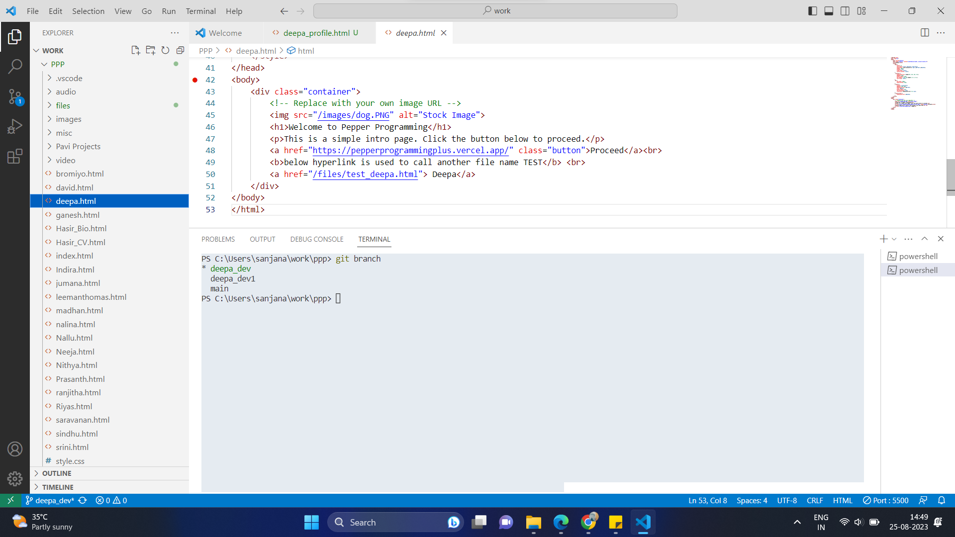

Git hub Repo:

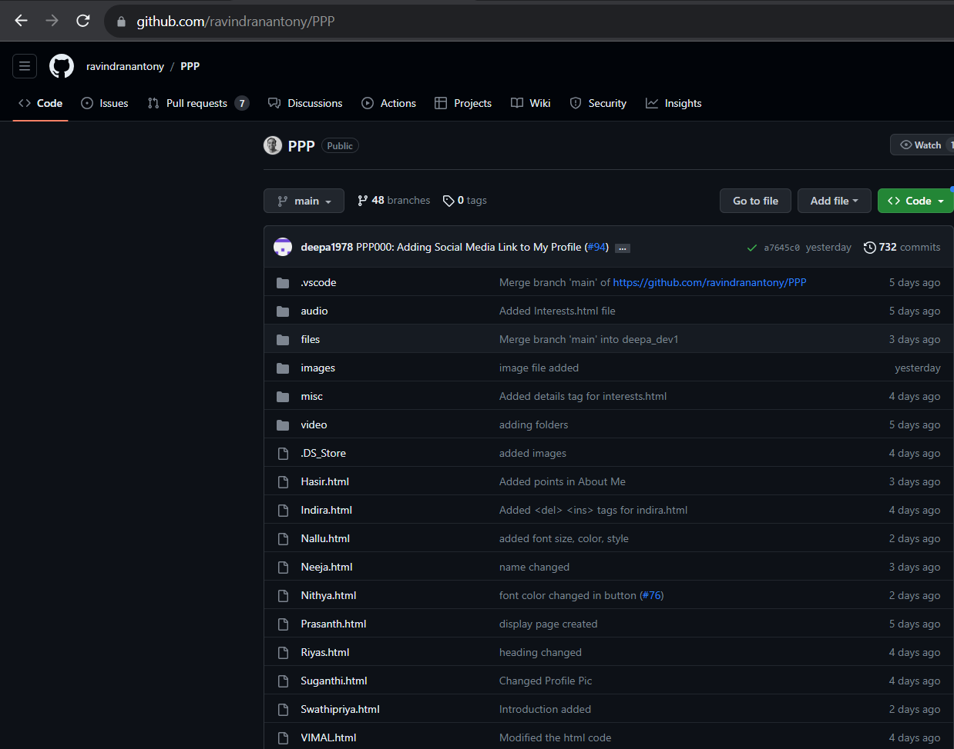

1. Added hyperlink in my name, linkedIn and resume:

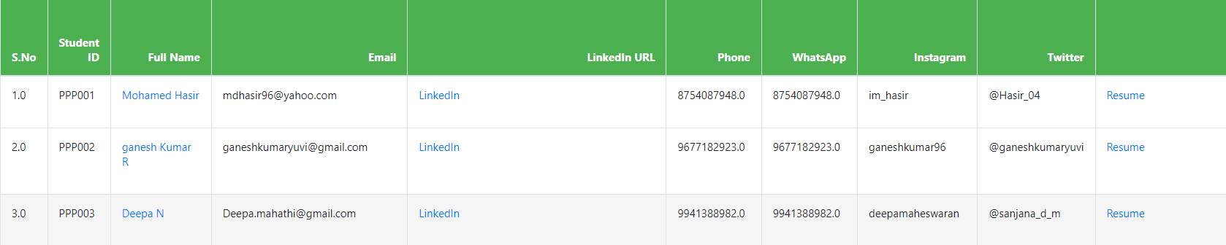

1. **Created a file with my name : Deepa.html**

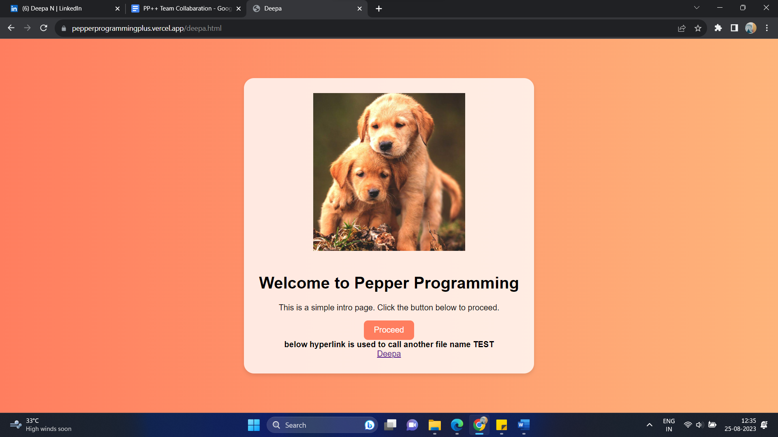

1. **created a file test_html to learn html:**

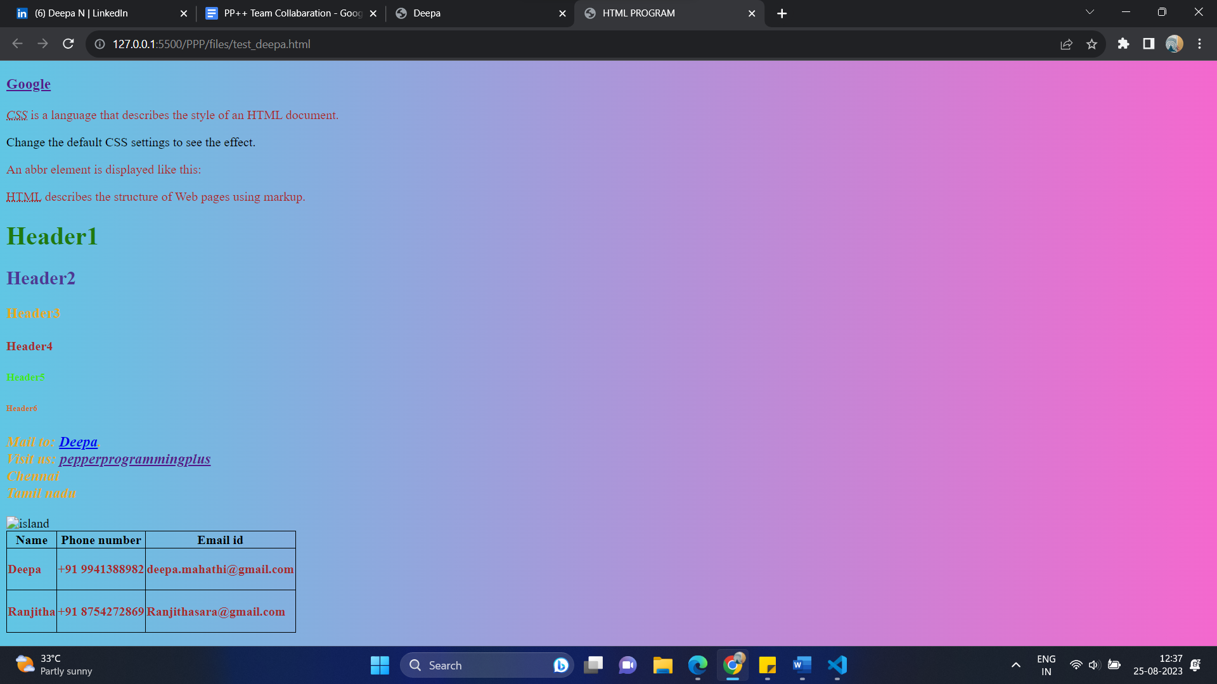

1. Modified the files and pushed it to git hub.
2. Created branches and push the file and from git hub pulled the request and added reviewer.

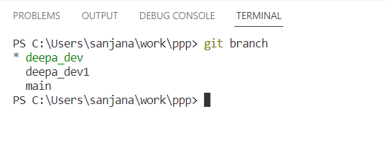

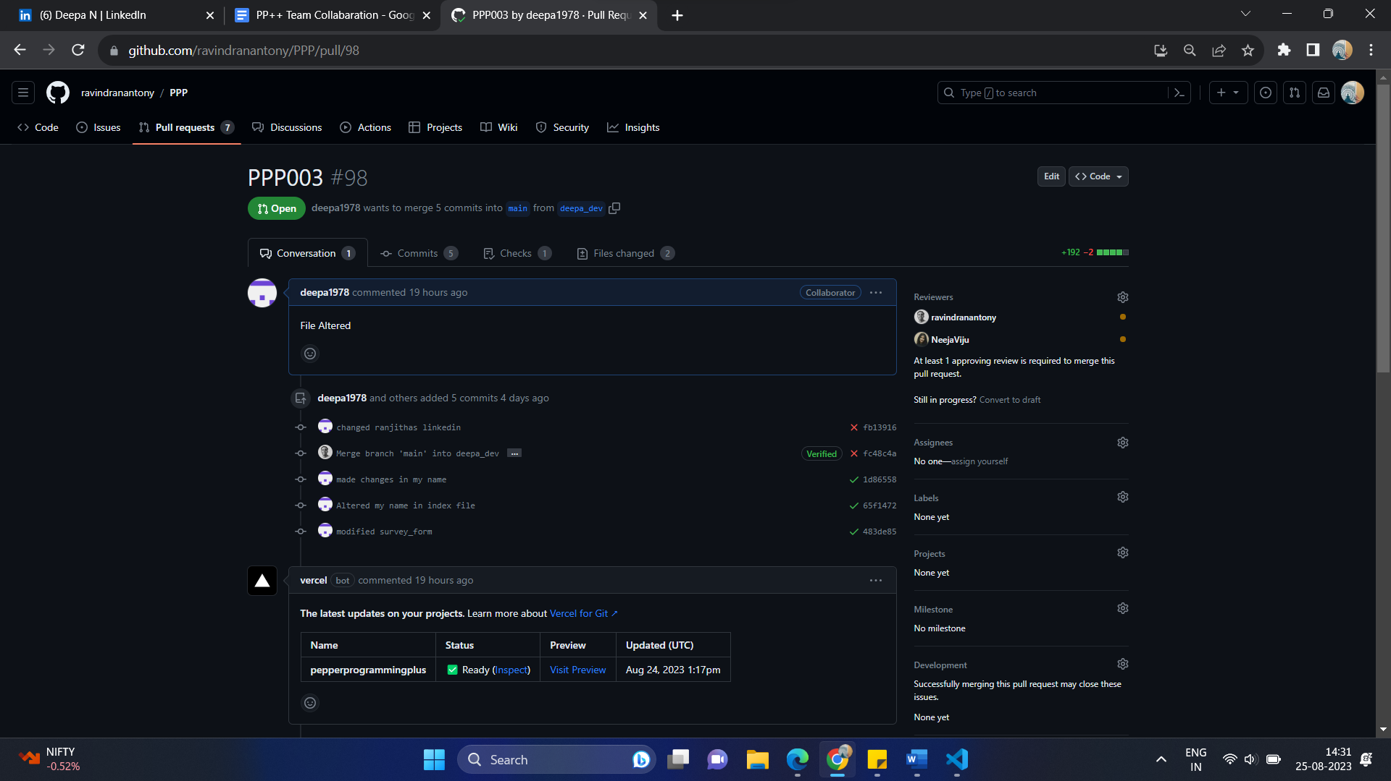

1. Created blog and posted the given topics. Shared them in Twitter with #PepperProgrammingPlus .

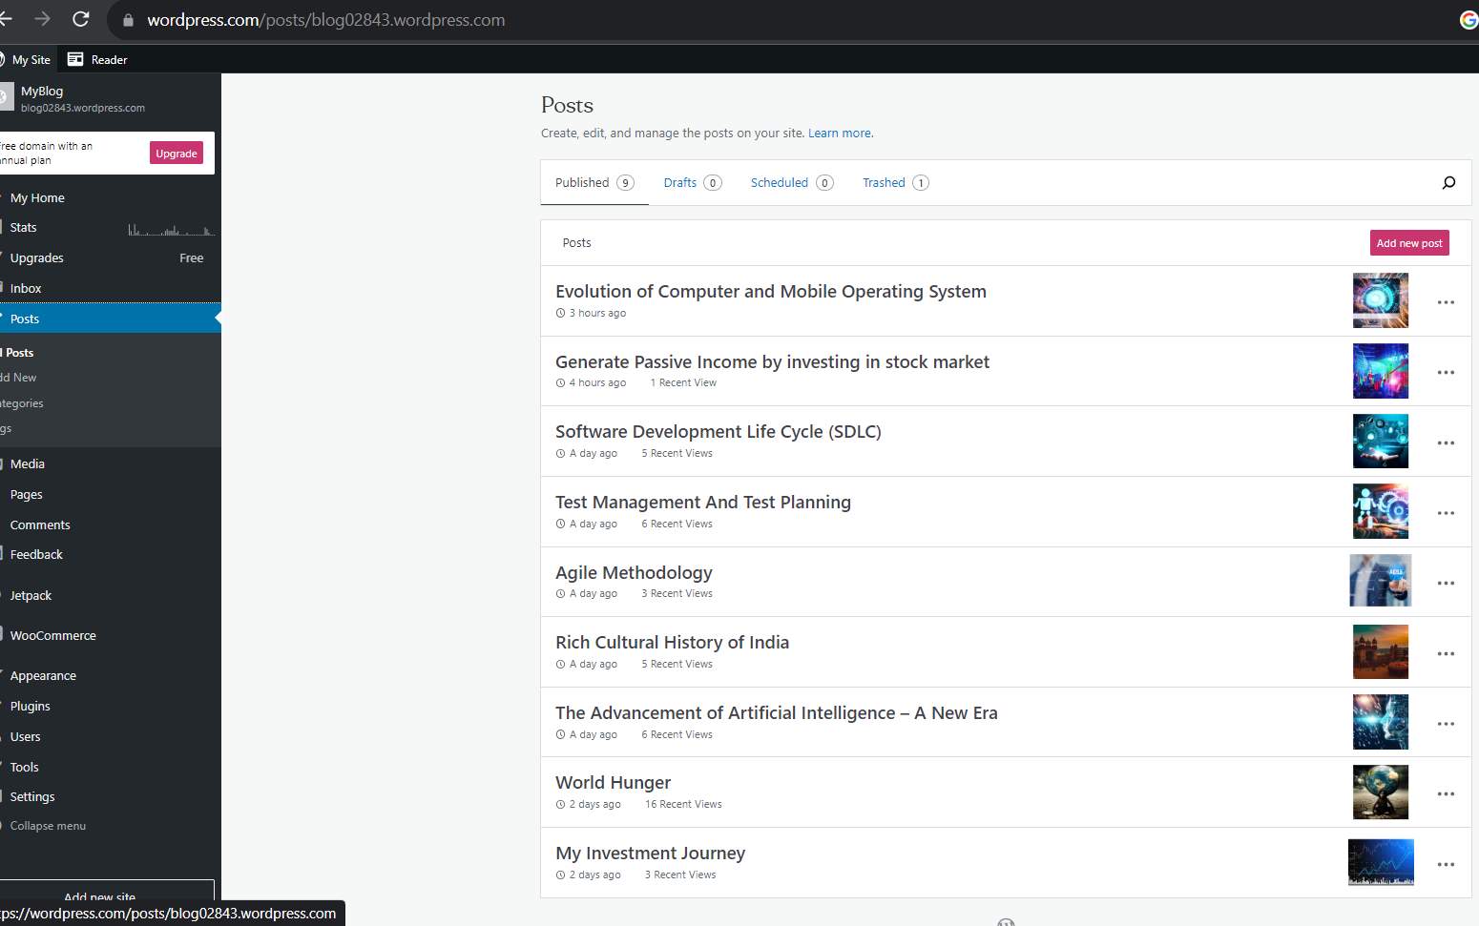

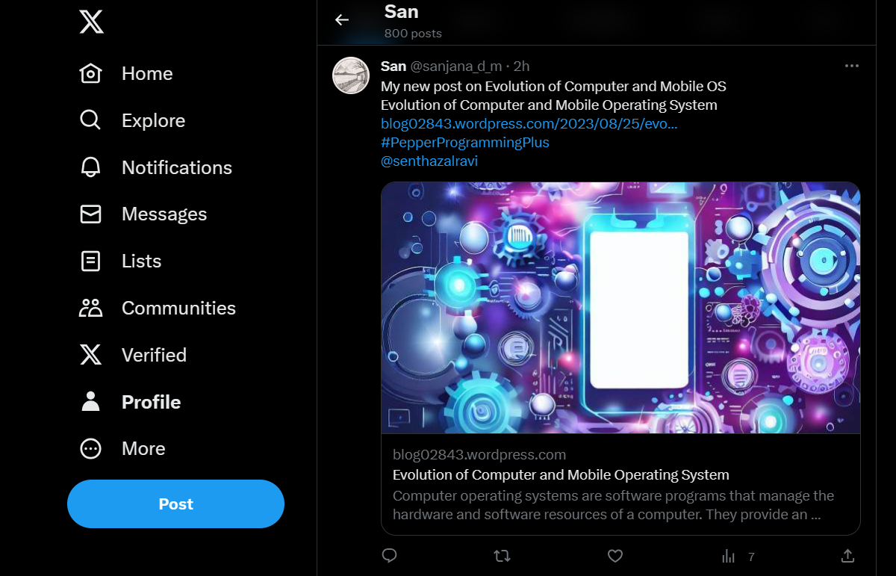

1. Modified LinkedIn Profile

